8. Dilate an Image Using the Dilate Function in Python
Aim: To read an image in Python and perform image dilation using the OpenCV dilate() function.
Procedure
- Import the OpenCV and NumPy libraries.
- Read the input image.
- Create a kernel for dilation.
- Apply the cv2.dilate() function to the image.
- Display the original and dilated images.
Code
import cv2
import numpy as np

img = cv2.imread("sample.jpg")

if img is not None:
kernel = np.ones((5, 5), np.uint8)
dilated = cv2.dilate(img, kernel, iterations=1)

cv2.imshow("Original Image", img)
cv2.imshow("Dilated Image", dilated)

cv2.waitKey(0)
cv2.destroyAllWindows()
else:
print("Image not found")
Input
An image named sample.jpg saved in the same folder as the Python program.
Output
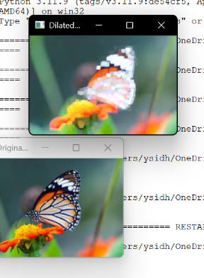
Result
The input image was successfully read and dilated using the OpenCV dilate() function.

